ORDINANCE NO. 532

AMENDING THE VILLAGE OF ROMEO, MACOMB COUNTY, MICHIGAN
ZONING ORDINANCE
AN ORDINANCE AMENDING THE ZONING ORDINANCE OF THE VILLAGE OF ROMEO, MACOMB COUNTY, MICHIGAN, To PROVIDE FOR THE BANKING OF THE NUMBER OF PARKING SPACES REQUIRED IN ZONING DISTRICTS IN THE VILLAGE OF ROMEO.
THE VILLAGE OF ROMEO ORDAINS:
Section The Village of Romeo recognizes that certain uses may function with less off-street parking than other uses permitted in the same zoning district. Notwithstanding the specific provisions of the Village Zoning Ordinance, banking parking spaces may be permitted at the request of an applicant if the applicant can demonstrate that the number of parking spaces requited under the Village of Romeo Zoning Ordinance is in excess of the actual requirements for the functional use of a building, for up to 65 % of the required number of parking spaces on the specific site, provided all the following conditions are met:
1. In no case shall banking of parking spaces be permitted for a parcel requiring 20 or fewer parking spaces,
2, An alternative parking site plan shall be submitted to the Planning Commission that conforms to the Village Zoning Ordinance, with the area where parking spaces will be banked clearly identified on the site plan, in addition to the areas where parking spaces will be initially constructed and used.
The alternative parking site plan shall show the number of parking spaces to be constructed and used, the number of parking spaces to be banked, and the layout of both parking areas. The areas designated for banking parking spaces shall be maintained as landscaped open space and may not be used for any other purpose.
- The applicant shall demonstrate that all proposed parking areas to be used and banked parking areas can be developed in accordance with Village, County and State standards and regulations, including, but not limited to, storm water management and wetland protection.
- Areas of land where parking construction has been banked shall be landscaped and maintained glass or other acceptable plant materials. If that area is not disturbed during construction, it may, with the approval of the Planning Commission, be maintained in the natural vegetative condition that existed prior to the development, provided the natural vegetation is in keeping with the general appearance of the area.
- In addition to the above requirements, approval for banking of required parking spaces shall be granted only upon a finding by the Planning Commission that the proposal meets all of the following

Requirements:
The applicant has demonstrated through substantial evidence that the specified occupant of the building, Of the use of the building, will require less parking than the number of parking spaces required by the Village of Romeo Zoning Ordinance.
(b) Parking shall not be permitted on any driveway.
Parking shall not be permitted in any area not approved and developed for parking.
Parking shall not be permitted in the area where parking space construction has been approved for banking until such time as that area is actually constructed for parking.
The requested banking of parking spaces shall not create traffic or circulation problems on or off site.
(f) The requested banking of parking spaces shall be consistent with the public health, safety and welfare of the Village and the purposes of the Village of Romeo Zoning Ordinance.
- The owner or occupant of property for which the banking of parking spaces has been approved shall report any proposed change in the use or occupancy of the subject property to the Village Building Official prior to said change, The building official shall evaluate the change and the site to determine if there is need for some or all of the banked parking spaces to be constructed and installed.
- Upon determination by the Building Official, or his/her designee, that some or all of the banked parking spaces need to be constructed and installed, the applicant shall construct and install the number of previously banked parking spaces determined by the Building Official prior to any change in the use or occupancy of the property. The Planning Commission may permit deferral of the construction and installation of banked parking spaces for up to six months from the determination of need made by the Village Building Official.
- In approving the banking of parking spaces, the Planning Commission may prescribe such conditions regarding the character, location, landscaping and other features that will, in its judgment, secure the objectives and purposes of the Village of Romeo Zoning Ordinance. Violation of such conditions, when made a part of the terms under which the banking of parking spaces is approved, shall be deemed a violation of the Village of Romeo Zoning Ordinance.
Section Repeal of Conflicting Provisions. All ordinances or resolutions, of parts thereof, in conflict with this ordinance ate, to the extent of such conflict, repealed.
Section Severability. If any section, paragraph, clause or provision of this amendatory ordinance is for any reason held to be invalid or unconstitutional by a court of competent jurisdiction, the invalidity or unconstitutionality of such section, paragraph, clause, or provision shall not affect any of the remaining provisions of this amendatory ordinance, which shall remain valid and enforceable.
Section Publication and Effective Date. This amendatory ordinance, or a summary hereof, shall be published in a newspaper of general circulation in the Village of Romeo, Macomb County, Michigan, within 15 days after its adoption and it shall be effective immediately upon publication.
A complete copy of this amendatory ordinance is on file and available for public inspection at the Village of Romeo Office, 121 W. St. Clair, Romeo, Michigan, 48065, during regular business hours, 9:00 a.m. to 5:00 p.m., Monday through Friday, excluding legal holidays.
ADOPTION OF THE AFORESAID ORDINANCE WAS:
MOVED BY:
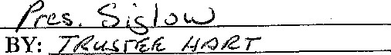
SUPPORTED BY:
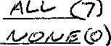
YEAS: NAYS:
(
7)
MADE, PASSED AND ADOPTED BY THE ROMEO VILLAGE COUNCIL ON THIS

DAY OF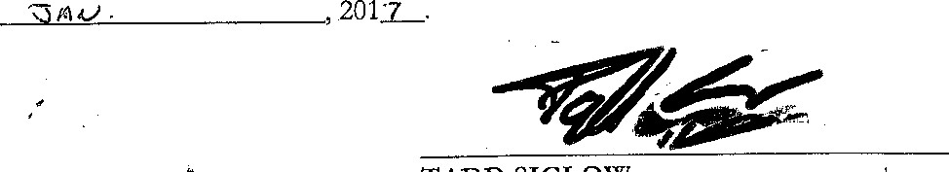
TADD SIGLOW
Romeo Village President
CERTIFICATE OF ADOPTION OF ORDINANCE
I hereby certify that the foregoing is a true copy of Ordinance No. 532_ , an Ordinance Amending the Zoning Ordinance of the Village of Romeo, was passed at the regular meeting of the Romeo Village
Council held on the q day of 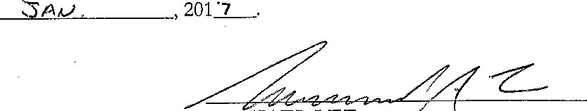

MICHAEL LEE
Romeo Village Clerk

